HitendraParmar 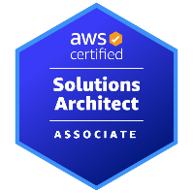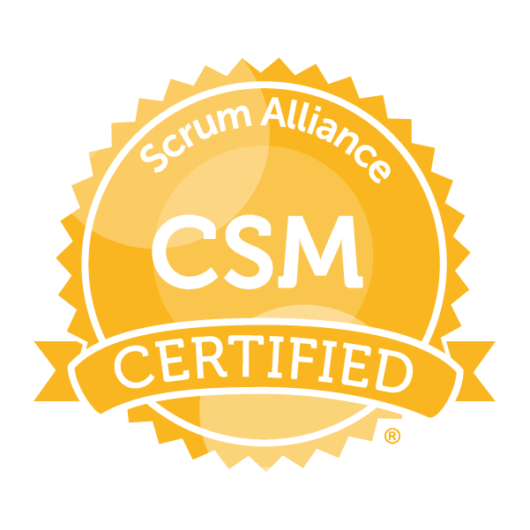
Email: supraja@sumascorp.com
Ph#: 512-649-4765

Professional Summary:

- Over 16+ years of IT experience as a DevOps Engineer in CI (Continuous Integration), CD (Continuous Delivery) and strong knowledge in solving complex problems with creative solutions, supporting development and operation environments.
- Strong experience in CI (Continuous Integration)/CD (Continuous Delivery) software development pipeline stages like Commit Build, Automated Tests, and Deploy in multiple environments like Dev, QA, and Pre-Prod & Prod.
- Extensive experience on working with the Configuration/Deployment Tools like ANSIBLE (Playbook, inventory) and CHEF (Knife, recipe, cookbook) and Puppet.
- Experience working with Chef Enterprise and Chef Open Source, Chef DK, Chef Workstation, Chef Server, Chef-Client.
- Experience in Amazon AWS Cloud which includes services: EC2, VPC, Route 53, S3, RDS, Dynamo DB, IAM, Cloud Formation, Pivotal Cloud Foundry, Cloud Watch, ELB, EBS, Lambda, SNS, SES, SQS and Cloud Formation.
- Experience in Terraform scripts which integrates numerous services on AWS like EC2 instances for different computational needs.
- Experience in Branching, Merging, and Tagging and maintaining the version across the environments using SCM tools like Subversion (SVN), GIT (GitHub, GitLab).
- Expertise in Source Code Management tools such as SVN, GIT and TFS administration.
- Expertise in using build tools like MAVEN, ANT & SonarQube for the building of deployable artifacts such as war & ear from source code.
- Hands on experience (Knowledge) on performance monitoring tools like Nagios and Splunk.
- Experience in working with container-based deployments using Docker, Docker images, Docker file, Docker Hub, Docker Compose and Docker registries.
- Experience with Docker and Kubernetes on multiple cloud providers, from helping developers build and containerize their application (CI/CD) to deploying either on public or private cloud.
- DevOps Practice for Micro Services using Kubernetes as Orchestrator and container orchestration with Docker.
- Experience in Installing and configuring Application servers such as Apache, Web logic, Web sphere, Jboss and Iplanet on LINUX server.
- Good understanding of the principles and best practices of Software Configuration Management (SCM) in Agile, Scrum and Waterfall methodologies.
- Collaborated with the SW development teams and ensuring products and services are pushed into production.
- Excellent communication, interpersonal, intuitive and analytical and leadership skills with ability to work efficiently in both independent and team work environment.

Technical Skills:

Build/CI Tools | Ant, Maven, Jenkins, Hudson, Bambo, Team City, Nexus
DevOps Tools | Chef, Puppet, Docker, Ansible, AWS, Nagios, Terraform, Kubernetes, SonarQube
Databases | MySQL, PostgreSQL, SQL Server
Web/App Server | Tomcat, WebSphere Application Server, JBoss, Nginx
Reporting Tools | Splunk, Nagios
Version Control Tools | Subversion, GIT, BitBucket
Technologies/Programming | Java Script, Java/J2EE, Perl, Python, Shell scripting, Bash, PowerShell
Operating Systems | Sun Solaris, Windows Server, LINUX, RedHat

Professional Experience:

DevOps Consultant
Vquest Technologies, Ahmedabad, USA | Oct 2024 – Till Date

- Developed and implemented Software Release Management strategies for various applications according to the agile process.
- As a DevOps Engineer need to coordinate and manage the entrance of new hardware and software into the Continuous Test Environment.
- Designed and created multiple deployment strategies using Continuous Integration/Continuous Development (CI/CD) pipelines and configuration management tools with remote execution to ensure zero downtime and shortened deployment cycles via automated deployments.
- Worked with Chef for all the software configurations and written multiple complex Cookbooks and Recipes for pushing the configurations to various enterprise nodes.
- Worked on using Chef Attributes, Chef Templates, Chef Recipes, and Chef Files for managing the configurations across various nodes using RUBY.
- Automated various infrastructure activities like Continuous Integration and Continuous Deployment using Ansible playbooks and has Integrated Ansible.
- Setup and build AWS infrastructure in various resources VPC, EC2, S3, IAM, EBS, Security Group, Auto Scaling, RDS in Cloud formation JSON templates.
- Used Terraform a tool for building, changing, and versioning infrastructure safely and efficiently. Worked with Terraform key features such as Infrastructure as code, Execution plans, Resource Graphs, Change Automation
- Developed build scripts using ANT and MAVEN as the build tools for the creation of build artifacts like war, ear files using CI/CD pipeline.
- Created GIT configuration record for builds using derived objects generated during build audit process. Implemented & maintained the branching and build/release strategies utilizing GIT.
- Used Jenkins to Build, Test and publish the project artifacts, Implemented Build per Branch as part of CI process to run Sonar for code coverage and run unit and integration tests to help improve the pipeline efficiency.
- Heavy scripting in Python and bash to build highly available server environments for teams deploying core products and services. Using AWS SDK built tools that automated AWS server provisioning, automated application.
- Built end to end CI/CD Pipelines in Jenkins to retrieve code, compile applications, perform tests and push build artifacts to Nexus.
- Responsible in building the micros service applications in the Docker, written the docker file to build the micro service and push the artifact to Artifactory.
- Managed kubernetes charts using the Helm. Created reproducible builds of the Kubernetes applications managed kuberentes manifests files and managed releases of Helm packages.
- Deployed the Docker images into the kubernetes using the Helm charts and template packaging.
- Participated in weekly release meetings with Technology stake holders identify and mitigate potential risks associated with the releases.
- Supporting large-scale web applications, we indexed database queries using MY SQL server by writing SQL queries. Responsible for the Plugin Management, User Management, Build/Deploy Pipeline Setup and End-End Job Setup of all the projects.
- Responsible for day to day Build and deployments in pre production and production environments.

Environment: Chef, Ansible, AWS (VPC, EC2, S3, IAM, EBS, Security Group, Auto Scaling, RDS), Terraform, SonarQube, CI/CD, Jenkins, Ant, Maven, Nexus, GIT, Docker, Kubernates, Artifactory, Python, Bash, JSON, SQL, Agile and Windows.

Role: Lead DevOps/Cloud Engineer. OneClick IT Consultancy Pvt Ltd | June 2019 – Aug 2024

- Participated in the release cycle of the product which involves environments like Development QA UAT and Production.
- Performed Continuous Integrated delivery (CI and CD process) using Jenkins and uDeploy. Created Pipeline as code in git which is integrated to Jenkins to develop full CI/CD.
- Implemented the Chef Software setup and configuration on VM's from the scratch and deployed the run-list into chef-server and bootstrap the chef clients remotely.
- Built and managed a highly available monitoring infrastructure to monitor different application servers and its components using Nagios with Chef Automation.
- Used Ansible Playbooks to setup Continuous Delivery Pipeline. Deployed micro services, including provisioning AWS environments using Ansible Playbooks.
- Involved in deploying and operating AWS, specifically VPC, EC2, S3, EBS, IAM, ELB, Cloud Formation and Cloud Watch using the AWS console and AWS CLI.
- Developed Templates for AWS infrastructure as a code using Terraform to build staging and production environments.
- Built and Developed scripts using Maven and ANT as build tools in Jenkins to move from one environment to other environments.
- Involved in writing shell/bash scripts to automate the administrative tasks using Cron jobs and managing them in the repository using GIT.
- Used the version control system GIT to access the repositories and used in coordinating with CI tools.
- Automated build and deployment using Jenkins to reduce human error and speed up production processes.
- Able to create scripts for system administration and AWS using languages such as BASH and Python.
- Develop custom dashboards to monitor user traffic load, response times and transaction on the websites using Splunk.
- Worked on Docker container snapshots, attaching to a running container, removing images, managing directory structures and managing containers.
- Worked with Kubernetes to automate deployment, scaling and management of web Containerized applications.
- Worked in development, testing, and production environment using SQL, PL/SQL procedure, Python, Ruby, Power Shell and Shell scripts and managed to host the servers like Web sphere and NGINX.
- Documented all build and release process related items. Level one support for all the build and deploy issues encounter during the build process.

Environment: Chef, Ansible, Terraform, AWS (VPC, EC2, S3, EBS, IAM, ELB, Cloud Formation), Jenkins, CI/CD, GIT, Bash, Python, Ruby, Power Shell, Docker, Kubernates, Splunk, SQL, NGINX, Agile and Windows.

Role: DevOps/Build/Release Engineer
LetsNurture Infotech Pvt. Ltd., India| Apr 2012 – Apr 2019

- Responsible for defining branching & merging strategy, checkin policies, improving code quality, automated Gated Checkins, defining backup and archival plans.
- Involved in developing Chef Recipes to configure, deploy and maintain software components of the existing infrastructure.
- Written Chef Cookbooks for Database and Application server configurations.
- Writing automation scripts using Ansible, Chef, and Puppet etc.
- Used Ansible as a configuration management tool for automations Linux machines deployment.
- Build servers using AWS, importing volumes, launching EC2, RDS, creating security groups, auto-scaling, load balancers (ELBs) in the defined virtual private connection (VPC).
- Creating AWS resources with Terraform and integrated with CD process. Used Terraform for building, changing, and versioning infrastructure safely and efficiently.
- Maintained build related scripts developed in shell for Maven and Ant builds. Created and modified build configuration files including POM.xml.
- Managed GitHub repositories and permissions, including branching and tagging.
- Involved in integrating GIT into the continuous Integration (CI) environment along with Jenkins.
- Worked on Jenkins adding the necessary plug-ins and adding more slaves to support scalability and agility.
- Worked on creating the Docker containers and Docker consoles.
- Maintenance and monitoring of Docker in a cloud based service during production.
- Used Jenkins and pipelines to drive all Microservices builds out to the Docker registry and then deployed to Kubernetes, Created Pods and managed using Kubernetes.
- Wrote Python and Bash scripts for databases maintenance and backup automation. Used Python based GUI components for the front-end functionality such as selection criteria.
- Used JIRA as a Change Management/ Work Management/SCRUM Agile Tool.
- Build, configured and support Application team environments.
- Established processes and tools to maintain code base integrity, including check-in validation rules and branch/merge processes.

Environment: Chef, Ansible, AWS, Terraform, Ant, Maven, GitHub, Jenkins, Docker, Kubernates, Python, Bash, MySQL, Jira, Agile and Windows.

Role: Build/Release Engineer
Pure Software Ltd ,India| August 2008 – Feb 2012

- Worked portal for triggering builds and releasing them to stakeholders by understanding the pain points of Developers and QA engineers.
- Create Chef Automation tools and builds and do an overall process improvement to any manual processes.
- Involved in setting up the Chef Workstation, Chef Repo as well as Chef Nodes.
- Designed and implemented Puppet , python scripts to deploy application changes and code.
- Worked in designing and deploying AWS solutions using EC2 instances, EBS, S3, RDS, Elastic Load Balancer and Auto scaling groups.
- Wrote ANT and MAVEN Scripts to automate the Build Process.
- Used GIT as source code repositories, Maintained and Administered GITHUB Source Code Tool.
- Integrated Continuous Integration system with GIT version control repository and continually build as the check- in's come from the developer.
- Have done various POCs to explain and demonstrate the possibility of implementing CI/CD in various projects.
- Use Jenkins to do daily and ad-hoc build and deploy. Set up new Jenkins job for new builds and deployment.
- Worked on various scripting language like Bash, Shell, Ruby, Perl and Python.
- Developed and maintained in-house Code review system before migrating to the lightweight code review system available in Stash.
- Designed and implemented the backup strategy for all the critical systems such as build machines, bug tracking tools, central repositories etc.

Environment: Chef, Puppet, AWS (EC2 instances, EBS, S3, RDS, Elastic Load Balancer), Ant, Maven, GitHub, Jenkins, Bash, Shell, Python, Ruby, and Windows.

